CVI620 – Assignment 1
Summer 2025

Total Mark: | 7.5 marks (7.5% of the total course grade)
Submission file(s): | - Assignment1.py or Assignment1.ipynb (you can upload multiple files)  - Assignment1.docx (this document with your answers)
Deadline | - October 11th, 2025

If you are unable to complete the assignment on-time for any legit reason, please provide documentation explaining your absence (e.g., an appointment confirmation or a work letter).
Please be aware that the assignment is designed to make you research and develop.

Please submit the submission file(s) through Learn@Seneca. Make sure to use GitHub and provide the link to your GitHub account for all your contributions in the box below:
Project GitHub repository:
Share with Ellie749 if private.

Please paste the resulting images and answers in this document.

Part I: Shapes

Recreate the OpenCV logo using OpenCV drawing functions only (e.g., cv2.circle, cv2.line, etc.).


You must draw:
- Three colored shapes (ellipse: Blue, Green, Red) arranged in a triangular pattern.
- Proper positioning and size of circles.
- The text "OpenCV" at the center/bottom.
Answer:
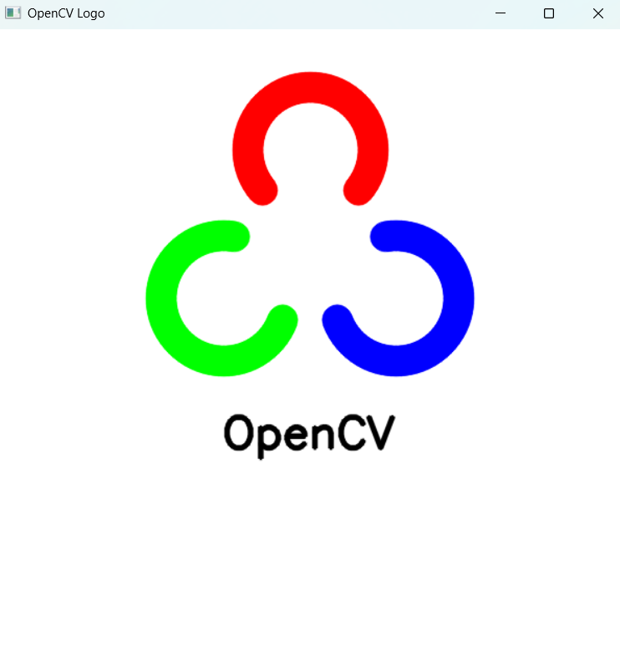
In this part, I used OpenCV’s drawing functions to recreate the OpenCV logo.
The image was created on a white background using three coloured arcs (Red, Green, Blue) arranged 120° apart in a triangular pattern.
The arcs were drawn using the cv2.ellipse() function, and a white triangular gap was created in the centre for accuracy.
The text “OpenCV” was added below using cv2.putText()

Part II: Image Arithmetic

You are asked to build a simple invisible cloak effect using OpenCV.
The idea is to make a specific colored cloth worn by the user become invisible by replacing it with the background.

Instructions:
Complete the function in A1_Q2.py file to implement the logic. The function should:
- Convert the image to HSV.
- Create a mask for green color using cv2.inRange() (you can use two ranges).
- Search about cv2.morphologyEx() and explain it in your code. Then use it on your mask if needed.
- Segment out the green area using the mask.
- Replace the green area with the background.
Upload your .py file and a attach few sample photos here.

Answer:
Background
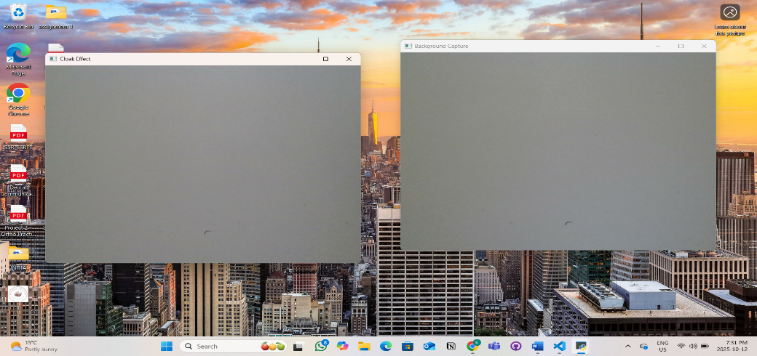
Cloak effect
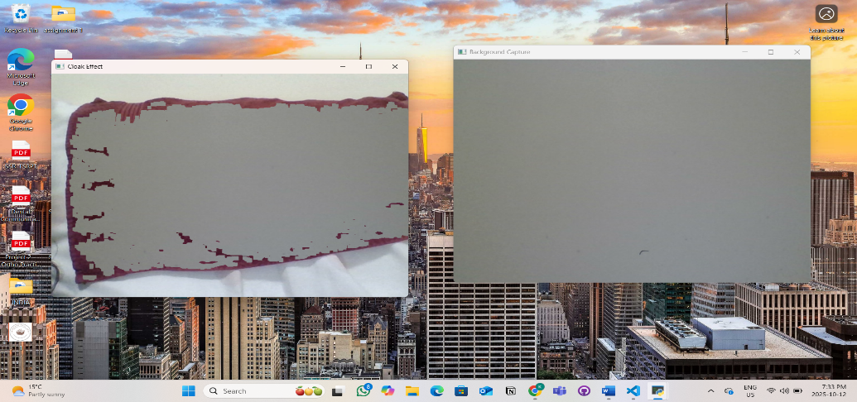

This experiment demonstrates color segmentation and masking using HSV color space in OpenCV.
The algorithm detects red regions by combining two HSV ranges ([0, 120, 70]–[10, 255, 255] and [170, 120, 70]–[180, 255, 255]).
Morphological transformations are used to clean up noise in the mask.
The red area in the live video is replaced by the pre-captured background, creating the illusion of invisibility.
Note:
A red cloth was used instead of green due to availability. The concept and processing steps remain identical — the only change is the HSV range for color detection.

Part III: A photo booth application

Design a modular photo editing application in Python using OpenCV and NumPy. The app should allow users to load an image and apply a sequence of processing steps interactively through a menu interface.

Required Functionalities:
- Load an image from file.
- Show the following menu:

==== Mini Photo Editor ====
1. Adjust Brightness
2. Adjust Contrast
3. Convert to Grayscale
4. Add Padding (choose border type)
5. Apply Thresholding (binary or inverse)
6. Blend with Another Image (manual alpha)
7. Undo Last Operation
8. View History of Operations
9. Save and Exit

- Brightness/Contrast
- Padding: Ask the user to specify the padding size and border type (constant, reflect, replicate, etc.). Additionally, include an option for the user to choose the padding proportion: Square, Rectangle, Custom Ratio (e.g., 4:5)
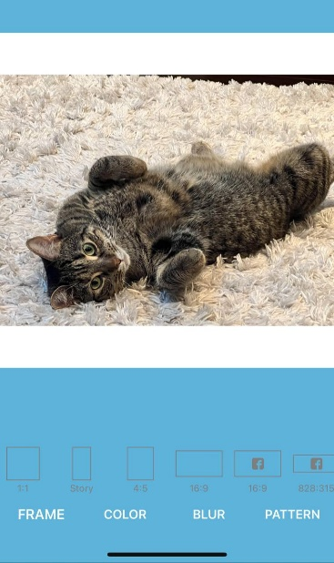

If the user selects a custom ratio like 4:5, your program should calculate and apply the padding so that the final image respects the chosen aspect ratio, regardless of the original size. The user should also be able to adjust the total padding size, and your code must maintain the proportion accordingly. (add smallest padding at the beginning to make it rectangle, then increase or decrease the padding size of the user wants)
- Thresholding: Let user choose between cv2.THRESH_BINARY and cv2.THRESH_BINARY_INV.
- Blending: Ask for a second image path and alpha (0 to 1).
- Undo Feature: Keep a history stack of image states. Allow the user to revert to the previous state.
- History Log: Keep a list of all actions performed (e.g., "brightness +50", "padded 20px with reflect"). Display the list before exiting or when requested.

Additional Requirements:
- Code must be modular. Each operation must be a separate function.
- Allow the user to apply multiple transformations in a row.
- When exiting, ask whether the user wants to save the final image, and under what filename.
- Use matplotlib to show side-by-side [original | preview] after every transformation.
- Include some of the results in this document.
Answer:
Brightness Adjustment
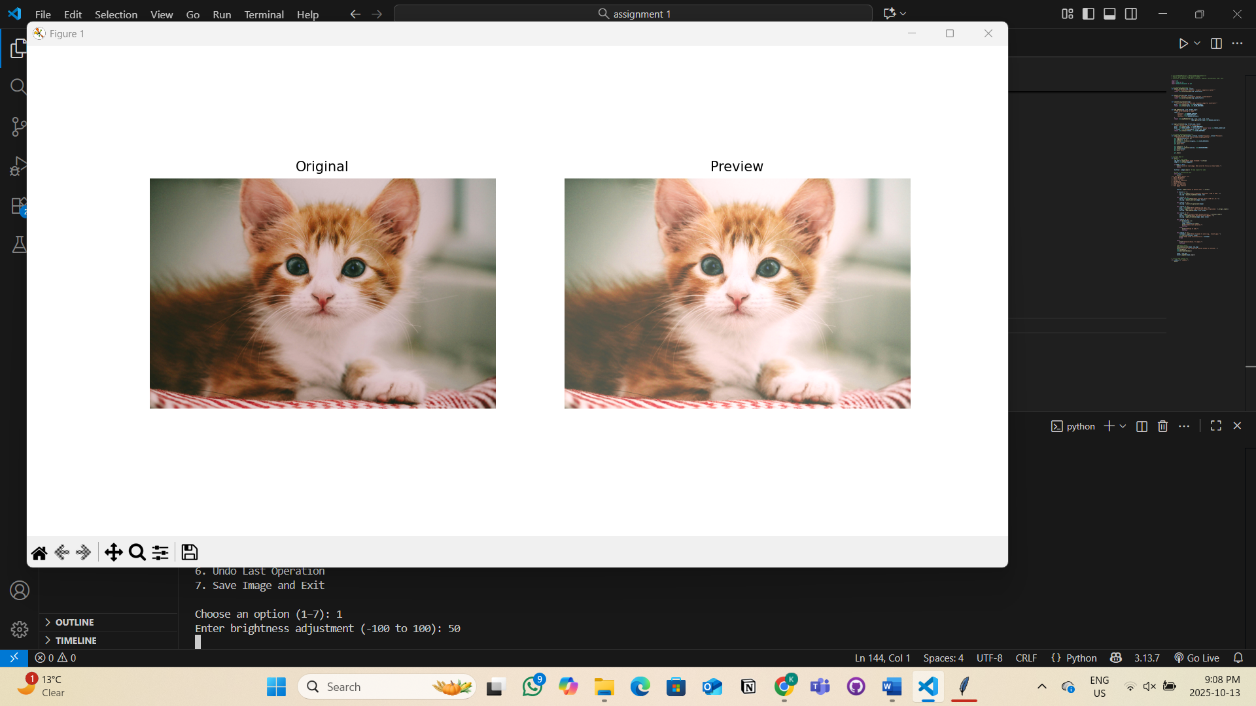
Contrast Adjustment
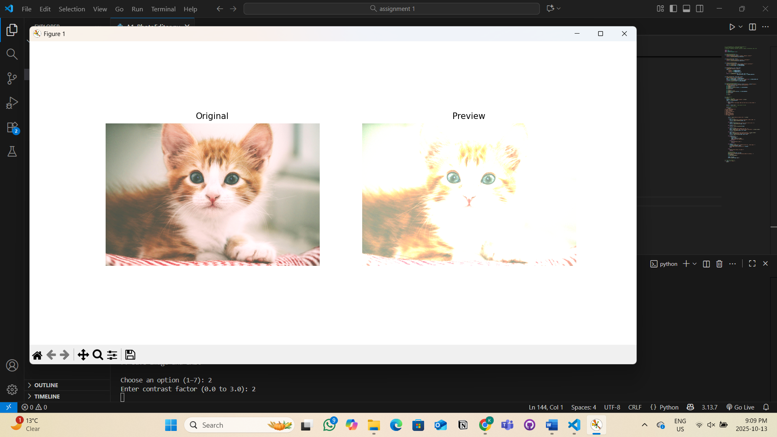
Operation Undone (6 option)
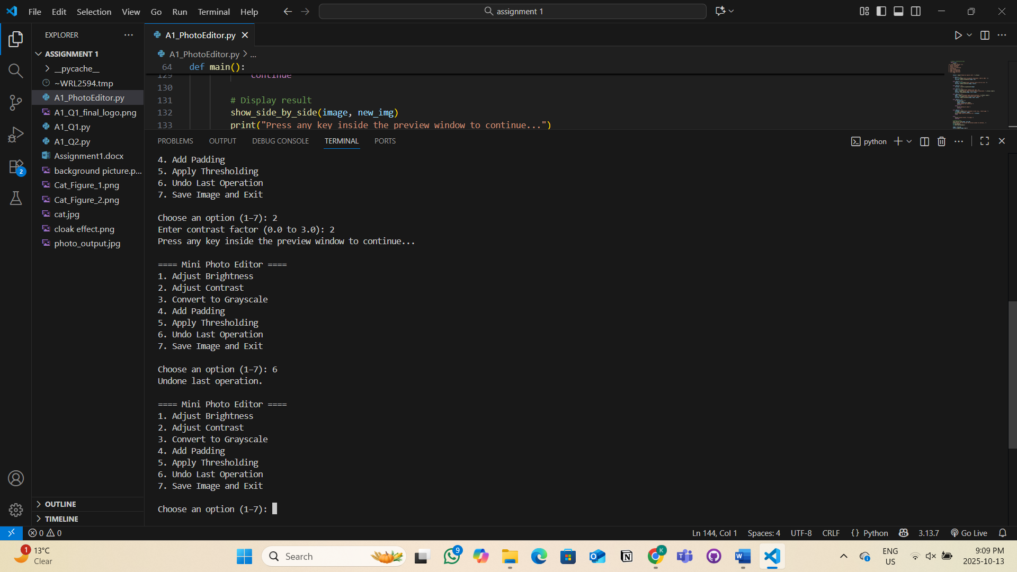
In this part of the assignment, I created a simple photo editing application using Python, OpenCV, and NumPy. The program allows the user to load an image and apply various effects such as adjusting brightness, changing contrast, converting to grayscale, adding padding, and thresholding. Each edit shows a before-and-after preview so that the user can compare changes. I also included an undo option to go back to the previous version and a save option to store the final image. The app runs entirely through a text-based menu in the VS Code terminal, making it interactive and easy to test.

Part IV:
Academic integrity Policy
I, Kavya Shah, declare that I have read and understood the Academic Integrity Policy.

GOOD LUCK!

